Product Specification
Item No: 7330  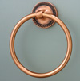 | Towel Ring  Product size: L: 16.5cm, H: 5.0cm, W: 19.0cm  Product Weight: 146g  Antique Copper Finish  Concealed Mounting

